Batch: E2 Roll No.: 16010123325

Experiment No. 5

Title: Hypothesis Testing
Aim : To perform hypothesis testing using the z-test and t-test in RStudio, and draw statistical inference from the results

Course Outcome:

CO2 : Gain necessary mathematical skills in probability, statistics, and basic linear algebra.

Books/ Journals/ Websites referred:
- The Comprehensive R Archive Network
- Posit

Resources used:
(Students should write the datasets used)
______________________________________________________________________

Theory:
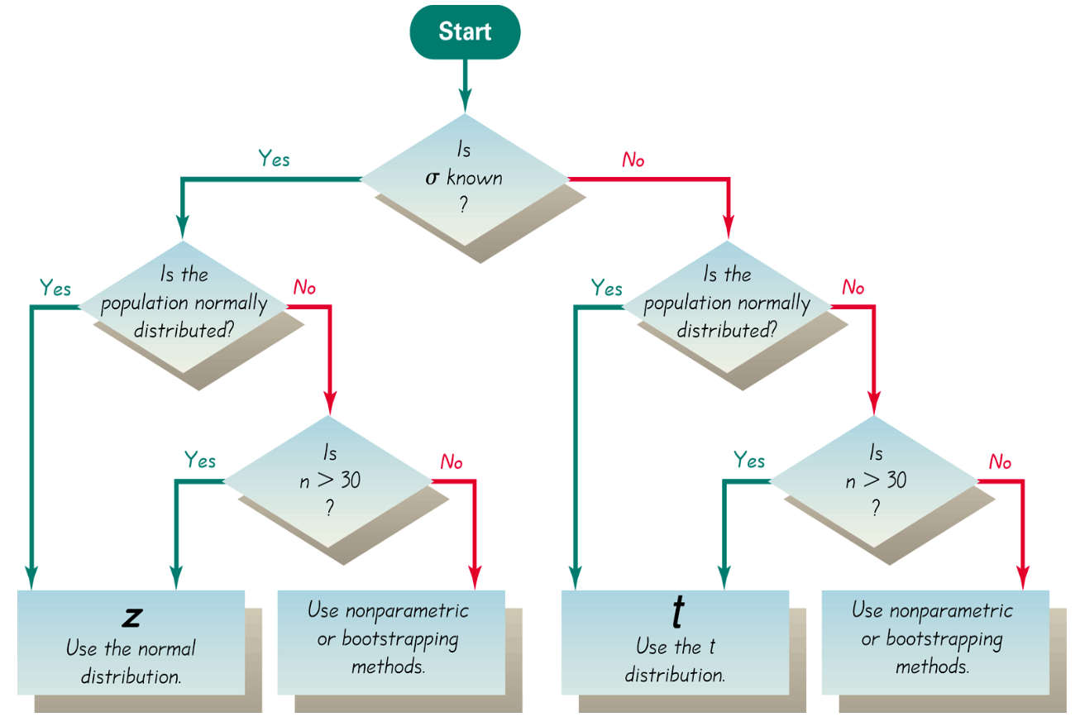

Implementation:
1. One-Sample Z-Test (One-Tailed)
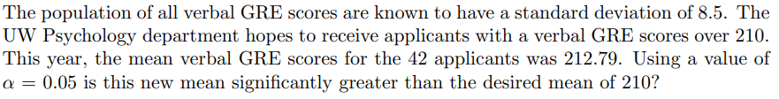
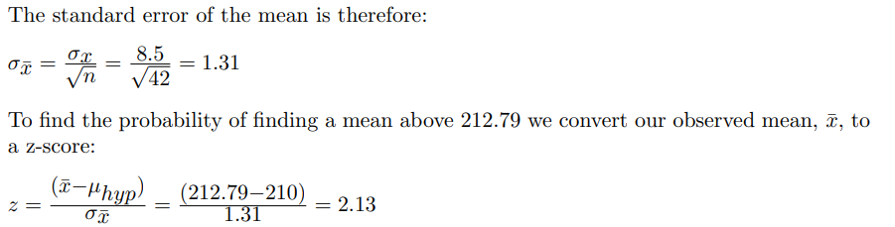
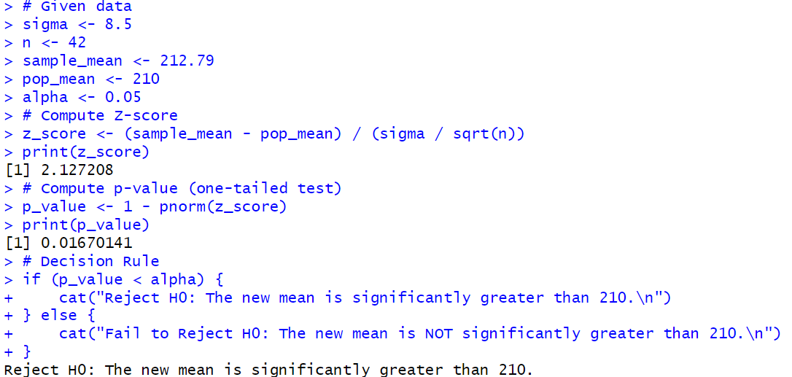

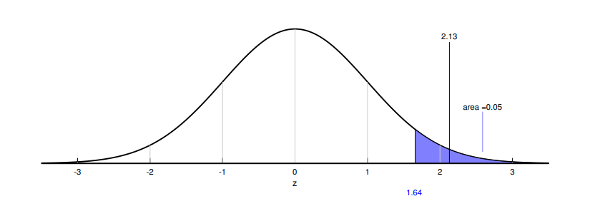
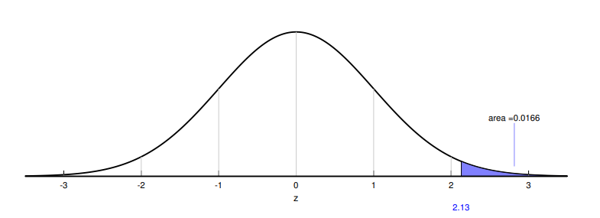
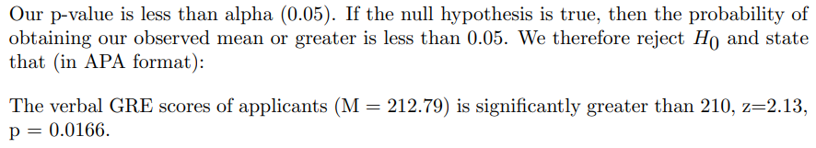
2. One-Sample Z-Test (Two-Tailed)
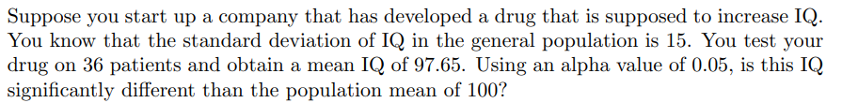
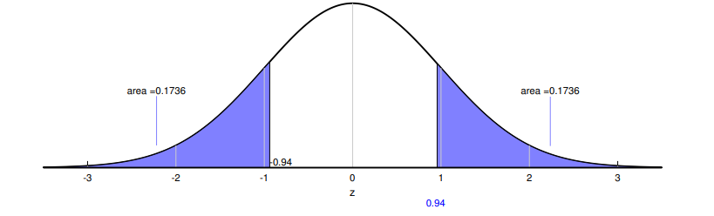

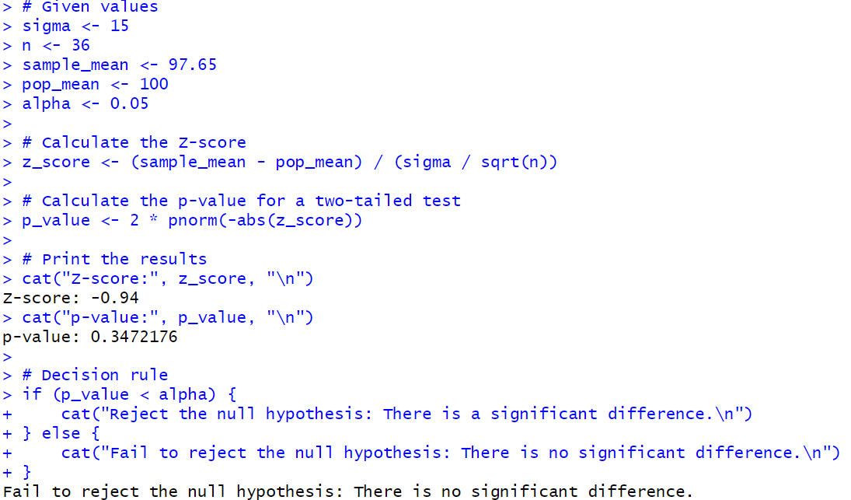
- Two-Sample Z-Test (Independent)
Example: Male vs Female Heights
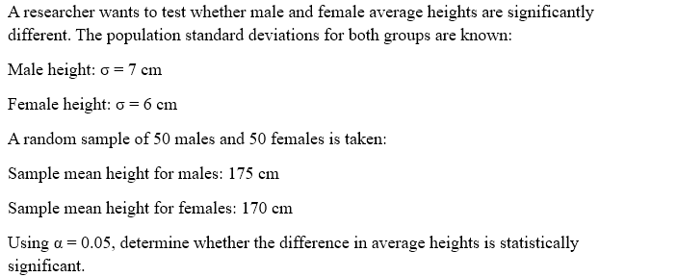
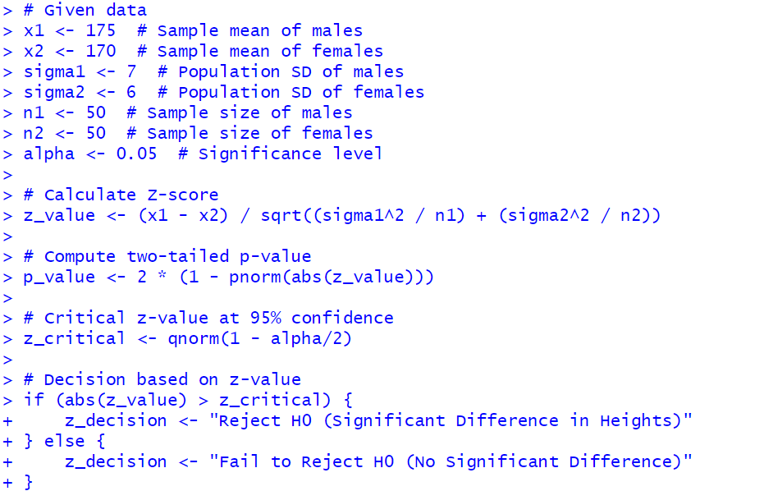
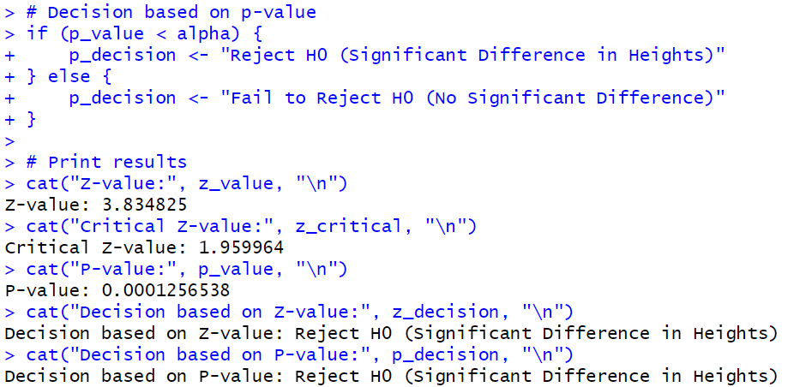
- Two-Sample Z-Test (Left-Tailed)
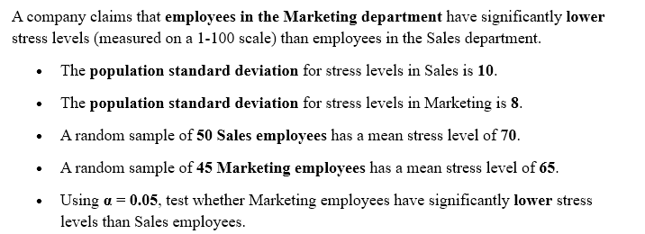
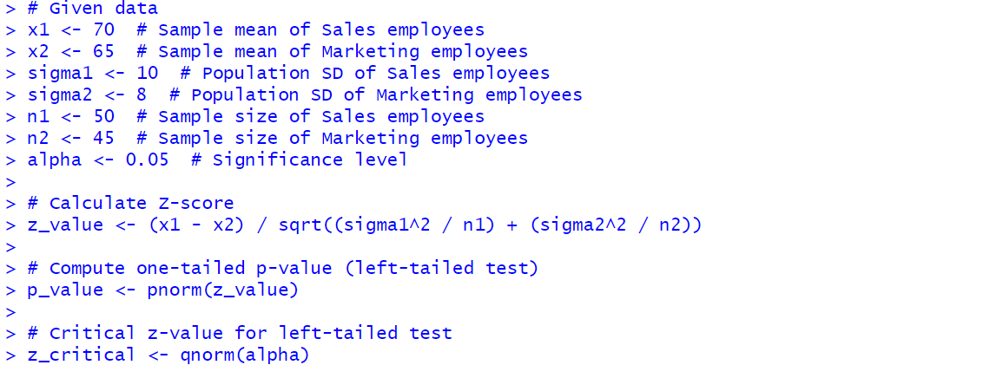
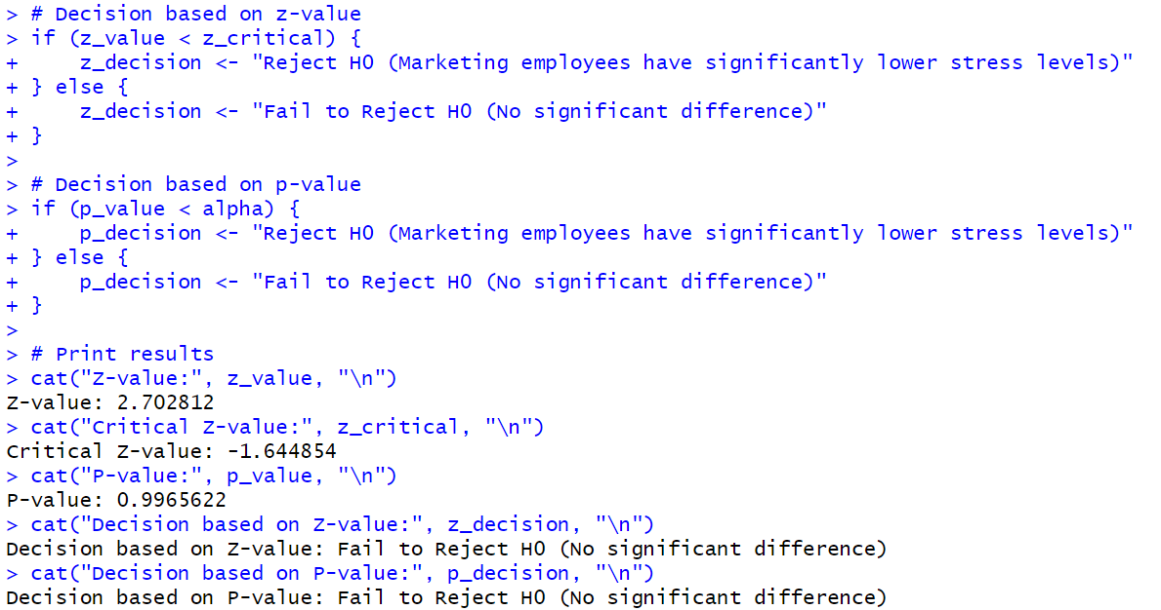
- Paired z-test
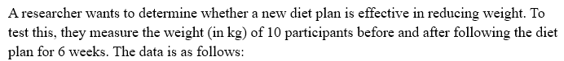
Participant | Before Diet | After Diet
1 | 70 | 68
2 | 75 | 74
3 | 80 | 78
4 | 85 | 83
5 | 90 | 88
6 | 72 | 70
7 | 78 | 76
8 | 82 | 80
9 | 88 | 86
10 | 95 | 92

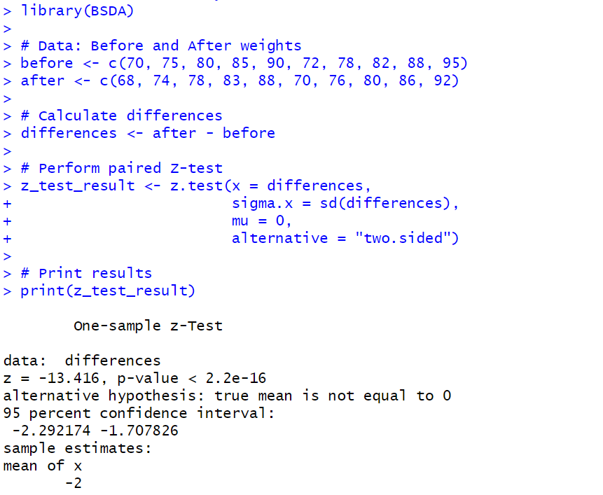

t-Tests:
1. One-Sample T-Test (Two Tailed)
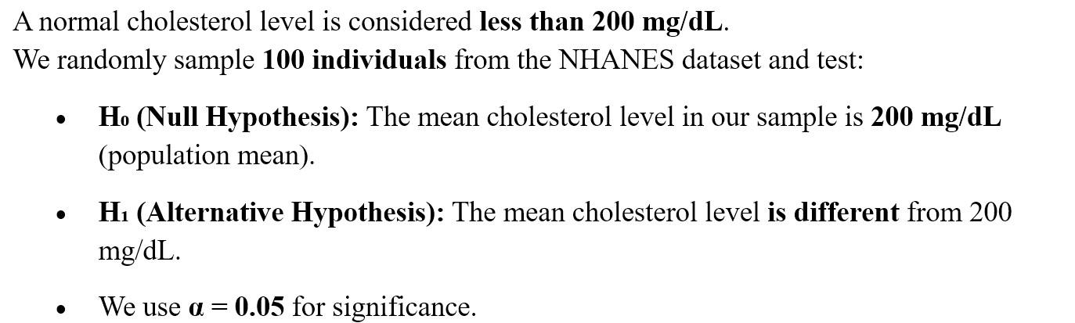

Checking the distribution of underlying data
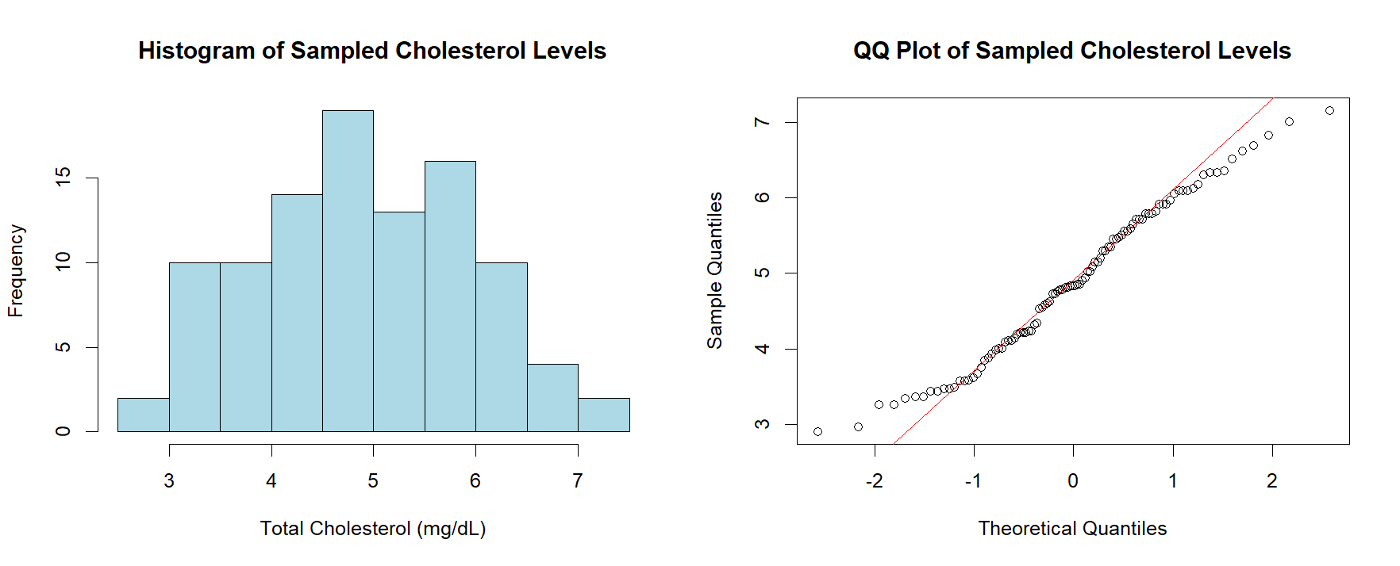
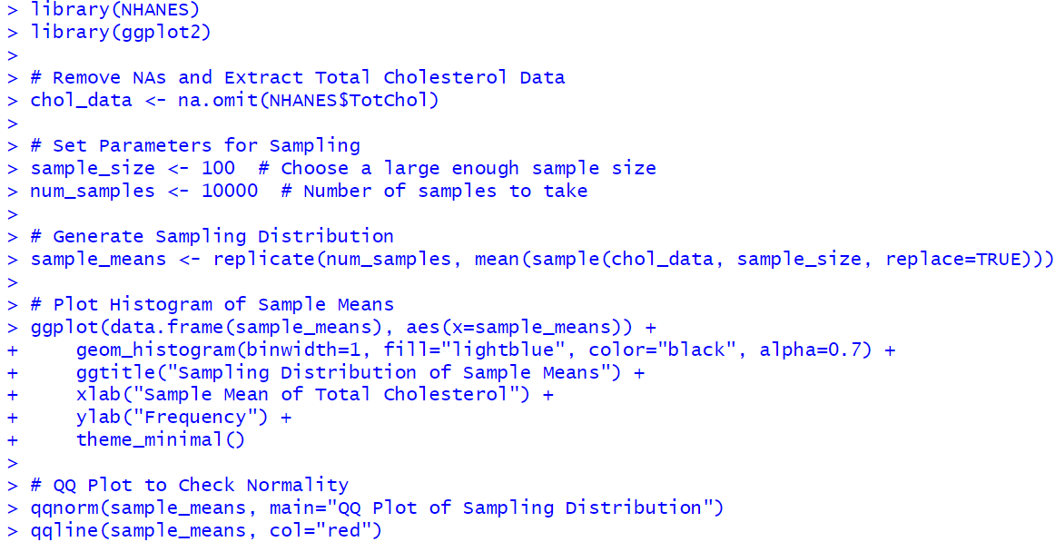
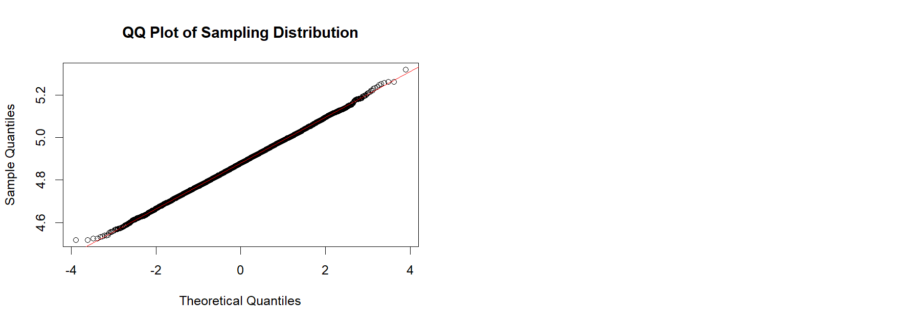
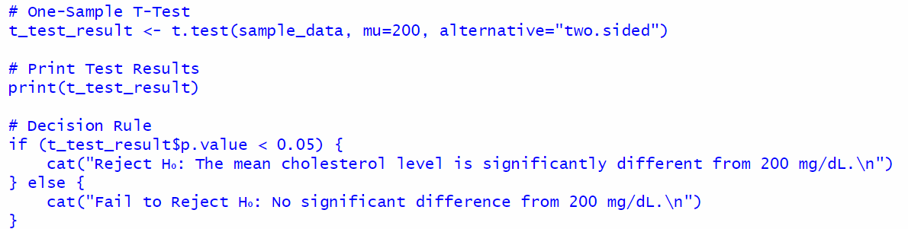
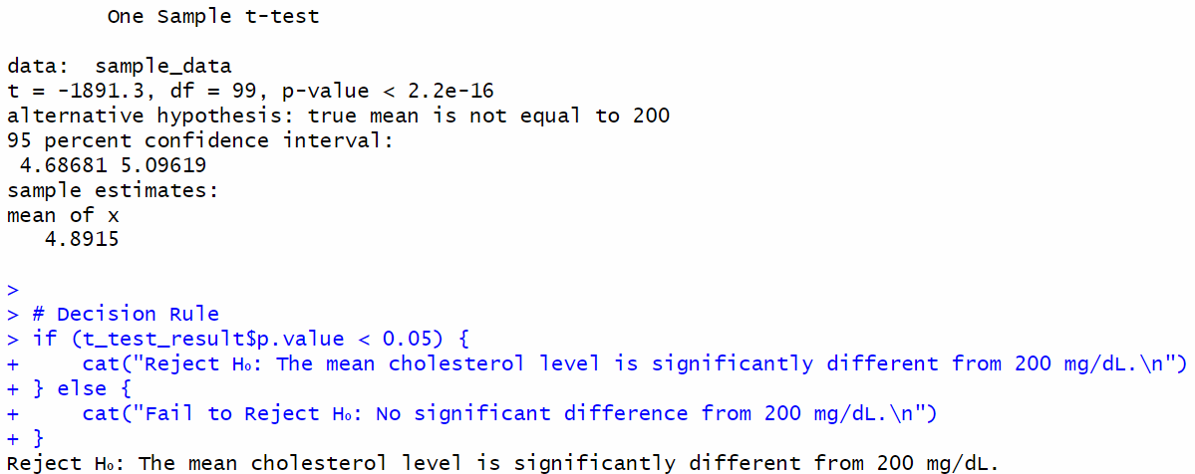

Students have to explore the datasets within R libraries, Kaggle, UCI or any other freely available data repositories, frame the null and alternate hypothesis on suitable attributes and perform all the z-tests and t-tests.
Students have to clearly mention the data sources, paste their code, and screenshots of output in the writeup.
Conclusion: Students should write in their own words.

A factory produces light bulbs with a known population mean lifespan of 1,000 hours and a standard deviation of 50 hours. A quality control team tests n = 36 randomly selected bulbs and finds that their mean lifespan is 1,020 hours. The team wants to determine whether the new batch of bulbs has a significantly higher average lifespan at a 5% significance level.
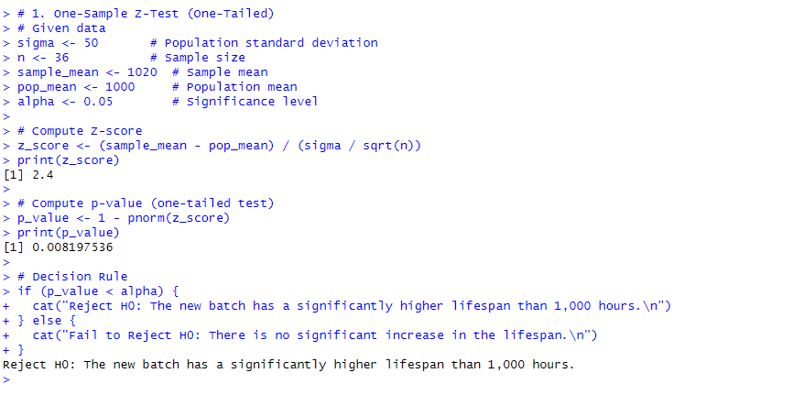
A company claims that the average weight of a certain type of packaged cereal is 500g. A quality control team selects a random sample of 40 packages and finds that the sample has an average weight of 495g with a known population standard deviation of 12g. The team wants to test whether the actual mean weight differs significantly from 500g at a 5% significance level.
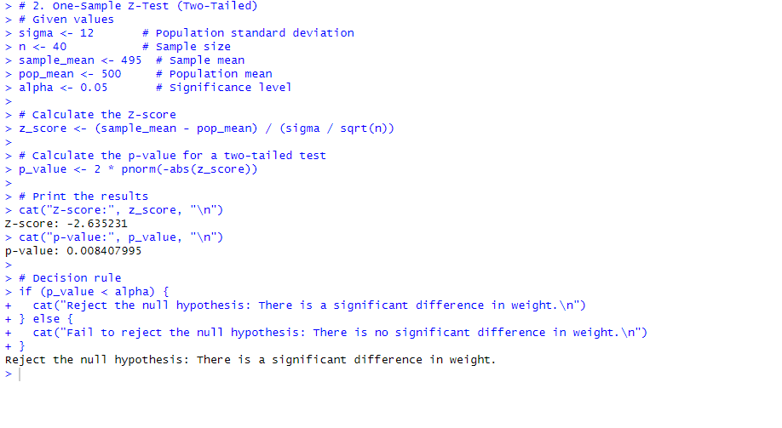
A researcher wants to compare the average test scores of two groups of students who used different study techniques.
- Group 1 (Technique A) has a sample mean score of 82, a population standard deviation of 10, and a sample size of 60.
- Group 2 (Technique B) has a sample mean score of 78, a population standard deviation of 12, and a sample size of 65.
- The researcher tests at a 5% significance level to determine if there is a significant difference between the two groups' average test scores.


A researcher wants to compare the reaction times (in milliseconds) of two groups of drivers:
- Young drivers (Group 1) have a sample mean reaction time of 280 ms, a population standard deviation of 50 ms, and a sample size of 55.
- Older drivers (Group 2) have a sample mean reaction time of 300 ms, a population standard deviation of 60 ms, and a sample size of 50.
- The researcher wants to test at a 5% significance level whether young drivers have significantly lower reaction times (i.e., faster reactions) than older drivers.

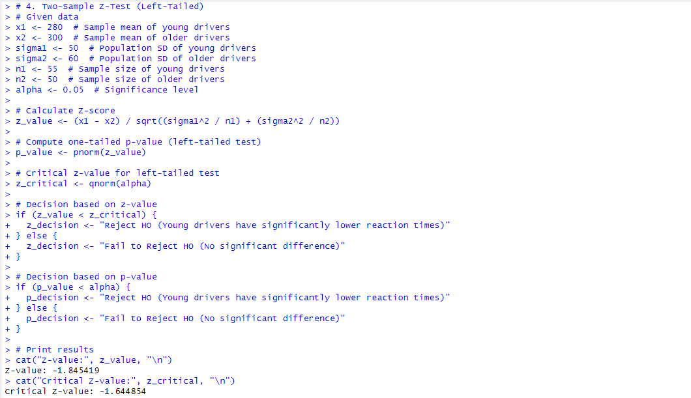

A fitness coach wants to analyze whether a new diet plan significantly reduces blood pressure levels.
- Blood pressure readings were recorded before and after following the diet for 8 weeks.
- We assume the population standard deviation of the differences is known.
- The coach conducts a paired Z-test to determine if there is a significant reduction.

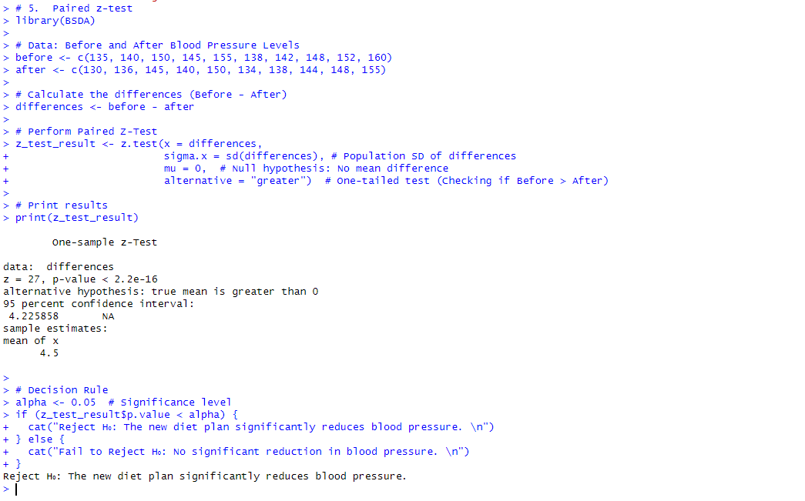

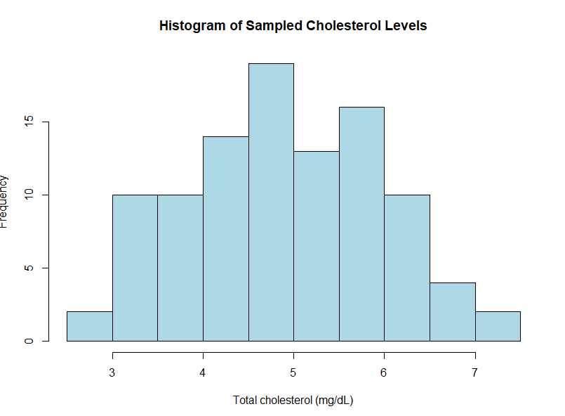


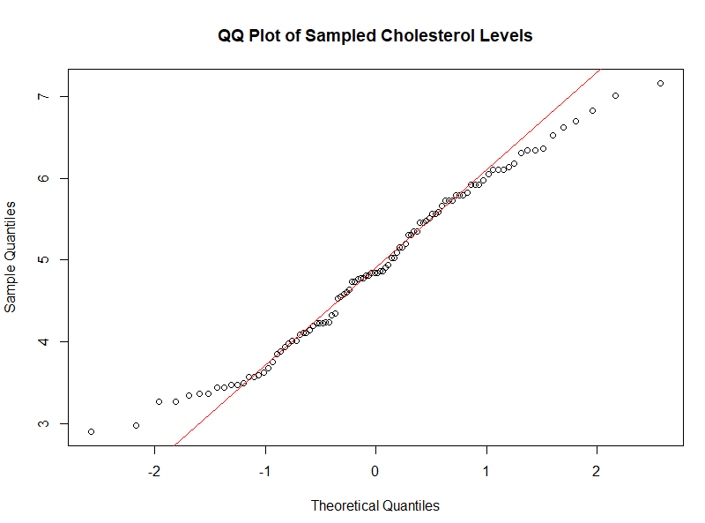

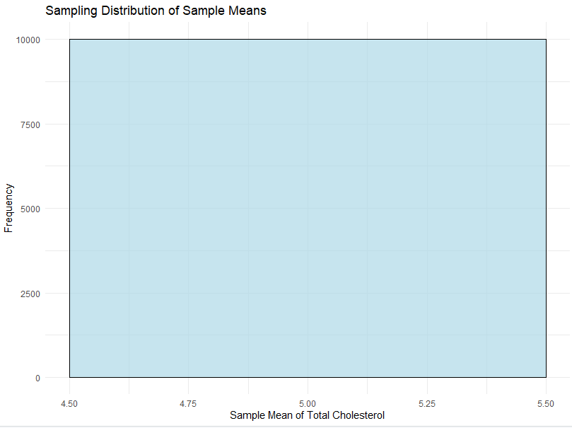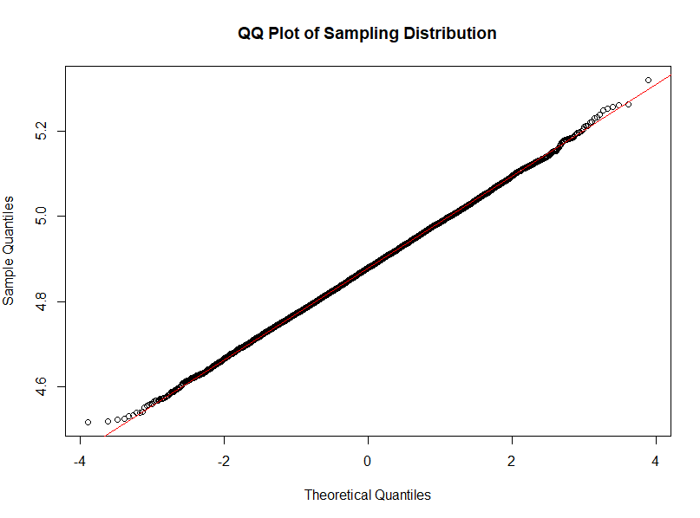
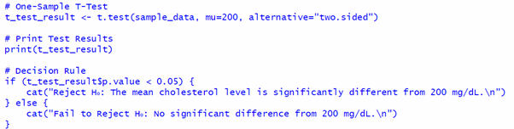
Post Lab questions:
- A university requires applicants to have a minimum GRE score of 320. You sample 36 applicants, and their mean GRE score is 322.5, with a known population standard deviation of 8. At α = 0.05, can we conclude that the average GRE score of applicants is significantly greater than 320?

- The average SAT Math score in a country is 500, with a known standard deviation of 100. You collect a random sample of 50 students, and their mean score is 520. At α = 0.05, can we conclude that the sample mean significantly differs from 500?
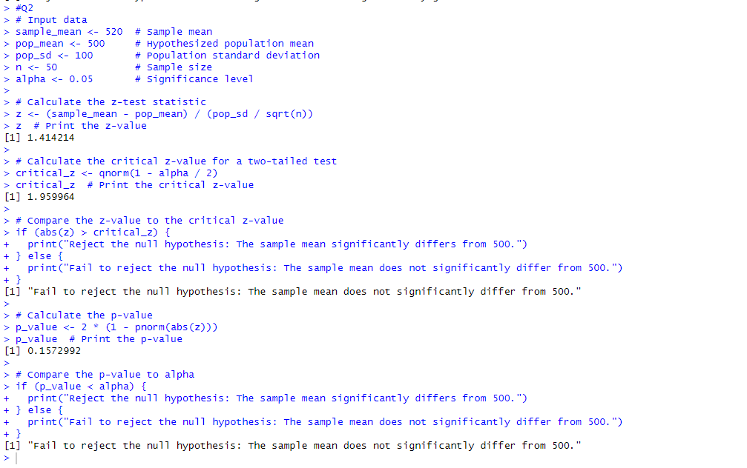
- A weight-loss program was tested on 20 individuals by measuring their weights before and after the program. The mean weight before the program was 80 kg (SD = 5). The mean weight after the program was 78 kg (SD = 4.5). The differences are assumed to be normally distributed. At α = 0.05, is the weight loss significant?

- When should you use a Z-test instead of a T-test? Explain with examples and discuss the role of sample size in determining which test to use.
-Test:
- Used when the population standard deviation (σ) is known.
- Suitable for large sample sizes (n ≥ 30) due to the Central Limit Theorem.
- Assumes data is normally distributed.
Example:
A university claims that the average GRE score of applicants is 320. If we sample 50 students and find a sample mean of 322 with a known population standard deviation (σ = 8), we use a one-sample Z-test to check if the mean is significantly different.

T-Test:
- Used when the population standard deviation (σ) is unknown.
- Suitable for small samples (n < 30).
- Uses sample standard deviation (s) instead of population standard deviation.
- More flexible for real-world scenarios where σ is often unknown.
Example:
A weight-loss program is tested on 15 participants by measuring their weight before and after the program. Since σ is unknown and n < 30, we use a paired t-test to analyze the difference.

Role of Sample Size:
- Large samples (n ≥ 30): The Z-test is preferred because sample means approximate normality due to the Central Limit Theorem (CLT).
- Small samples (n < 30): The T-test is used as it accounts for increased variability in small samples using Student’s t-distribution.

